Water cycle game documentation
Summary
The water cycle story is a 2D platform game. It will be created as an educational tool to teach children about the water cycle. The player plays through the game as a water drop and must progress through various platform challenges, obstacles and enemies to complete each stage of the cycle.
The game will be developed using the JavaScript and HTML. There is no set budget for the game as it is being donated to various schools and teachers. It has a development cycle of around 6 months with testing and bug fixes included in this time limit.

Game world & setting
The game world is based on the educational topic of the “water cycle”. Each level will be a different stage of the water cycle and the level flow will change dependent on the stage for example on the underwater level, the player will spawn at the bottom of the level and finish at the top.
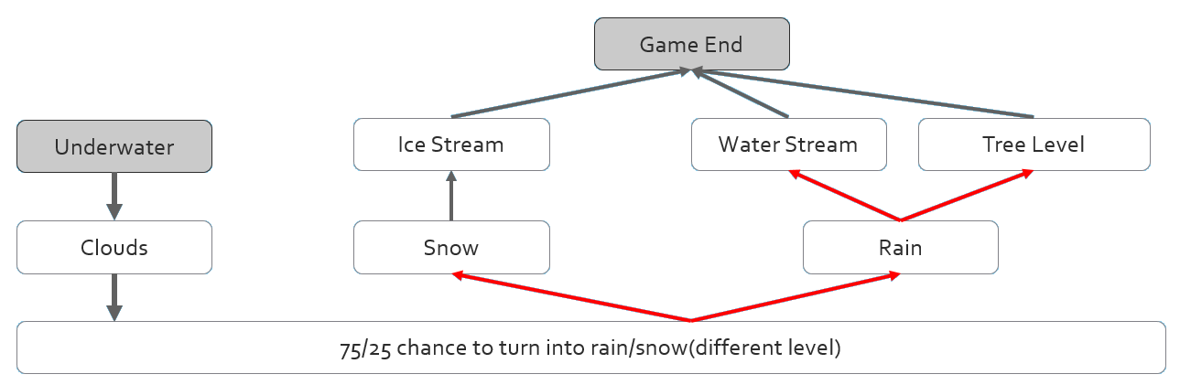
The game world has a stationary time element in order for the weather state to stay the same throughout each level. Once a level is complete, the next stage of the cycle will commence putting the player in a different environment.

Characters
The water drop is a lone drop confused to which way he needs to go in order to complete his cycle and be with his family again.

The sunshine gang are enemies of all different species. They took on the name sunshine gang as they aim to bring constant sunshine to the world and bring an end to the water cycle by evaporating all of the world’s water.



Game progression
The player progresses through the game when they reach the specific objective for example in the first level the player needs to reach the top of the ocean to evaporate. With the changes on how different levels will require the player to progress such as level start and end positions, it will offer depth in the platforming aspects by allowing the player to use different platforming game play elements to progress through the game.

Game story
The water drop wakes up lonely in the ocean to discover that his family have already started to progress through the water cycle. The water drop gathers some courage and sets off in the first stage of his water cycle. Through evaporation, the water drop discovers the sunshine gang and their plan of constant sun and bringing an end to the cycle. The water drop can’t put an end to them alone and must inform his family of the sunshine gang and avoid them as he progresses through the water cycle.

Game controls
The controls of the game will use keyboard and tablet touch controls. The images below show the controls and how the player moves the water drop in game.
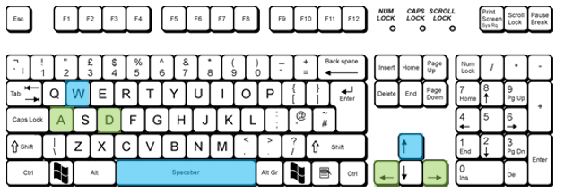
Keyboard
Left: A or left arrow key.
​
Jump: W, space bar or up arrow key.
​
Right: D or right arrow key.
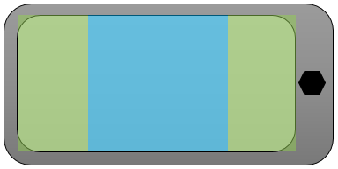
Phone/ tablet
Left: 25% of the screen on the left side.
​
Jump: 50% of the screens center.
​
Right: 25% of the screen on the right side.

Rules and boundaries
For the water cycle project, we chose to have a fairly lenient rules and boundaries where there isn’t any strict rules the player has to follow. As the objective of the game is to complete one lap of the water cycle, the one rule and boundary the player has to follow is they must reach the end of each level without dying.
​
There are multiple enemies in each level that will teleport the player to the spawn location if they touch. We also made the decision not to have the player require every coin in order to progress as the games demographic is primarily children and we didn’t want it to be too challenging to complete.

Feedback
There are a few feedback indicators that let the player know they are doing the right thing. On certain levels there are visual indicators such as signs and the general gist of the level pushes the player to progress as there are a very minimal amount of dead ends or places the player can wonder off to.
​
There’s also sound feedback when a collectible coin is collected to let the player know it’s obtained. I feel this also gives the player an incentive to collect them to find out if there’s a special sound or ending to be seen or heard.

Interface
When the game starts, the player is greeted with the title screen which states the name of the game and also a simple instruction of tap to start. Each level has its own splash screen before it starts to tell the player the backstory of the level. After the game is won or lost, the respective game ending screen will appear telling the player how well they did in terms of coins collected, lives remaining and other information.
​
In terms of level interface, each level has a constant pinned GUI which tells the player how many lives they have and how many coins they have collected.

Context sensitivity
All the content in this game is appropriate for all players. There is an option to mute any soundtracks or sound effects if the player is sensitive to audio. Our team has also made sure not to use any colour combinations that can cause discomfort to people with colour blindness. We have also made sure not to use any flashing lights or colours in order to keep players that suffer from seizures, safe.

Goals and challenges
The main goal of the water cycle story is to finish the game and complete the water cycle. We made this the primary goal as we know when compared to other games of the same demographic, this one is more challenging than most.
​
If the player chooses, they can collect all the coins or even try to complete the game with 100% completion. When the game is won, it tells the player their completion percentage requiring all coins and no lives lost. A timer is also implemented so if the player chooses to, they can try challenges such as beating a specific time while still getting 100% completion.

Environment
Our team chose to go with various environments in order to accurately represent the water cycle. The player will play as a water drop in a 2D environment in 7 possible locations.

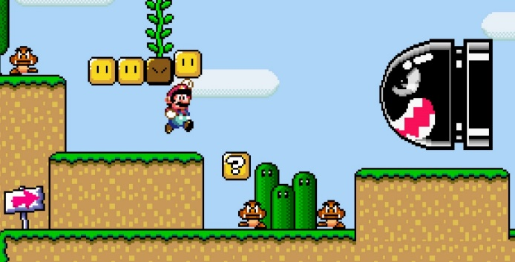
The first level is set underwater where the player must reach the top of the ocean in order to evaporate into the clouds which is where the next level is set. After the player has fallen from the clouds they will be falling from the sky over a mountain background. Once fallen, the first path the player can take is a standard landscape which is covered in snow and ice. If the player continues as rain, the next level will either be set in a water stream or inside a tree.
​
The games art style will be Pixel art which this uses bold colours and pixelated images. A big influence for the chosen art scheme is Super Mario world for the SNES. This game was able to display vibrant and detailed sprites while still working within their pixel limit.

Balance
In terms of difficulty the game has a constant balance of difficulty and doesn’t progressively get more difficult as the levels go up. We chose to make every level really challenging so the player absorbs more information, has a lot of replay value as players will then try to beat it with fewer lives lost and will generally stay more memorable when compared with a game that can be completed in a few minutes.

Platform
The game is created for low specification computer systems, tablet and mobile devices.
It is to be used primarily at Open Days, school visit days and as a downloadable game from the Teacher Resource area on the University Website.

Target audience
The demographic is mainly primary school children who are currently learning about the water cycle. Although the target audience is primarily children, game play elements such as a speed run timer will allow the game to be played by anyone.

Development time
The Development time would be around 6 months, with development to start on the 18th of September and a full game release scheduled for the 19th of March.

Week 4 - Prototype
Week 7 - Friends and family alpha testing
Week 11 - Alpha testing
Week 14 - Beta testing
Week 19 - Early access launch
Week 23 - Full release

Disclaimer
All of the content in the game treatment above was done by me, William Daniels (50%), and Nathan Robinson (50%).

References
Keyboard-r1-6. (2011). [image] Available from: <http://www.bristol.ac.uk/it-services/learning/documentation/keyboard-1/keyboard-1r.html> [Accessed 25 Nov. 2016.]
Nintendo (n.d.). Super Mario Screenshot. [Image] Available at: https://www.gamestm.co.uk/wp-content/uploads/2015/01/super-mario-world-glitch-2.jpg [Accessed 19 Oct. 2017].

